**[How To: Create DMG Art for Fancy Application Installations](http://mac101.net/content/how-to/how-to-create-dmg-art-for-fancy-application-installations/)**

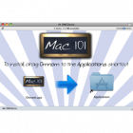

August 11, 2009 in [How-To](http://mac101.net/category/how-to/) by [Mark](http://napkinsketch.com)

In this series we go over how to create DMG disk image artwork for use with your apps or applications. Having a professional looking installation folder is critical to your apps image, and rather simple to achieve good results.

Quick Nav:

1. [Create a Background](http://mac101.net/content/how-to/how-to-create-dmg-art-for-fancy-application-installations/#1)
2. [Create a Custom Size DMG](http://mac101.net/content/how-to/how-to-create-dmg-art-for-fancy-application-installations/#2)
3. [Background Folder](http://mac101.net/content/how-to/how-to-create-dmg-art-for-fancy-application-installations/#3)
4. [Place your Files or App](http://mac101.net/content/how-to/how-to-create-dmg-art-for-fancy-application-installations/#4)
5. [Create Applications Shortcut](http://mac101.net/content/how-to/how-to-create-dmg-art-for-fancy-application-installations/#5)
6. [Change Icons](http://mac101.net/content/how-to/how-to-create-dmg-art-for-fancy-application-installations/#6)
7. [Hide Folder](http://mac101.net/content/how-to/how-to-create-dmg-art-for-fancy-application-installations/#7)
8. [Change the Views](http://mac101.net/content/how-to/how-to-create-dmg-art-for-fancy-application-installations/#8)
9. [Arrange Icons and Re-size Window](http://mac101.net/content/how-to/how-to-create-dmg-art-for-fancy-application-installations/#9)
10. [Compress Image](http://mac101.net/content/how-to/how-to-create-dmg-art-for-fancy-application-installations/#10)
11. [Results](http://mac101.net/content/how-to/how-to-create-dmg-art-for-fancy-application-installations/#11)

**Step 1: Create a Background**

I would recommend using a size such as 700px by 400px, however you can use any size you want.

Save the file as DMG and set it aside for a future step.

Note: Please post up your artwork, we would love to see what our Members have created!

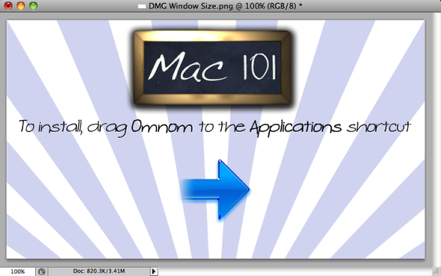

**Step 2: Create a Custom Size DMG**

First Create a DMG according to your size requirements, to do so follow the instructions in our other post [Create Encrypted DMG Disk Images](http://mac101.net/content/how-to/security-create-encrypted-dmg-disk-images-sensative-data/)

*Be sure to not use encryption, which would enable password protection.*

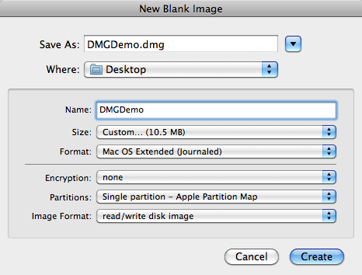

**Step 3: Background Folder**

The DMGDemo.dmg should of automatically mounted, double click on the mounted DMG.

Create a folder inside the mounted dmg and name it â€œ**background**â€. Drag the background image we created into the mounted DMG’s background folder. The background image needs to reside inside DMG, otherwise when the DMG is opened on another system it will be looking at the wrong location, and not a localized folder on the DMG.

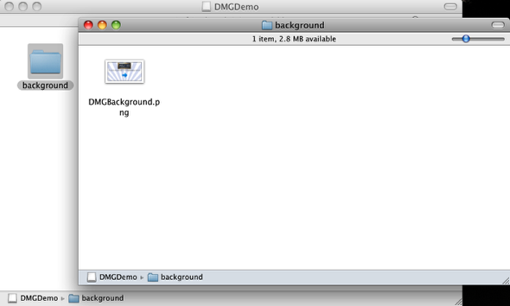

**Step 4: Place your Files or App**

Drag your app file onto the DMG, we will rearrange them once we setup the background image.

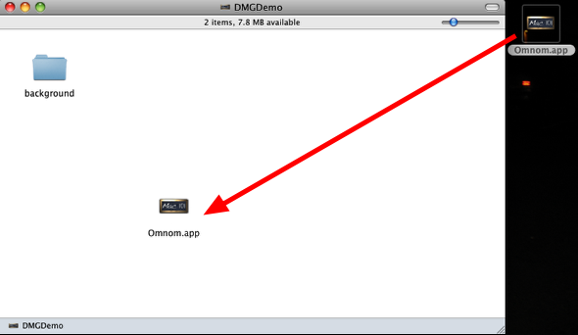

**Step 5: Create Applications Shortcut**

Open your root hard drive and Right click on Applications and select **Make Alias.** Drag the Applications alias onto the DMG.

Rename the Applications alias as “**Applications**”

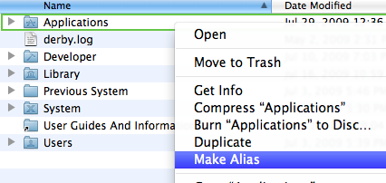

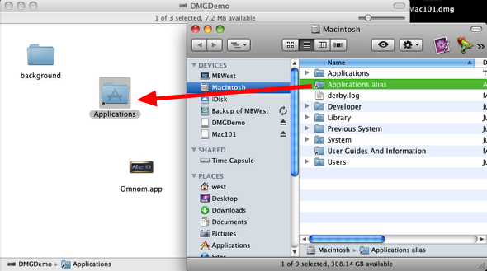

**Step 6: Change Icons**

First find the icon your wish to use (generally the same as your Application), it can be any volume, application, file, or folder icon. Simply click on the icon and hit **Cmd + C** to copy the Icon.

Right click the Mounted DMG icon from the Desktop, and choose choose **Get Info** or press **Cmd + I.**

Click the icon in the upper-left corner.

From the Edit menu, choose Paste or press **Command + V** to replace the icon.

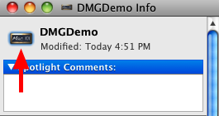

**Step 7: Hide Folder**

Make sure you have Developer tools installed, aka xcode. If you do not, [go download it!](http://developer.apple.com/Tools/xcode/) – note, you will need to be a ADC (Apple Developer Connection) Membership, but don’t worry its free.

Open Terminal and perform the following command to hide the background folder.

/Developer/Tools/SetFile -a V /Volumes/your_image_name/hidden_folder

your_image_name : in this case, â€œDMGDemoâ€  
hidden_folder : in this case, â€œbackgroundâ€

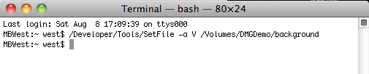

**Step 8: Change the Views**

Right click in the DMG and select **Show View Options**, or your can simply press **Command + J**.

1. Change the Icon size to whatever works best with your design, we will be using 128 x 128.

2. In Background: select **Picture**, and drag your background we created to the “Drag image here” section.

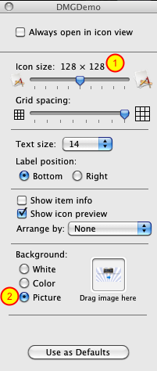

**Step 9: Arrange Icons and Re-size Window**

Rearrange the icons to your liking, they will stay in place.

Resize the window so it matches up with your background image.

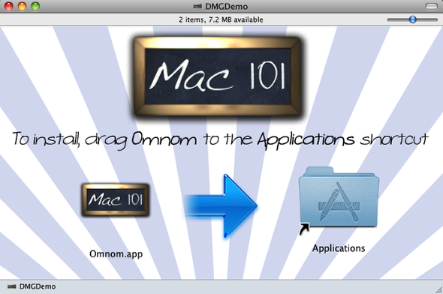

**Step 10: Compress Image**

Right click the DMGDemo mounted image and select Eject.

Open **Disk Utility** and right click the DMGDemo.dmg and select **Convert…**

Image Format: select **compressed**  
Enryption: Not needed, but you can select it if desired.

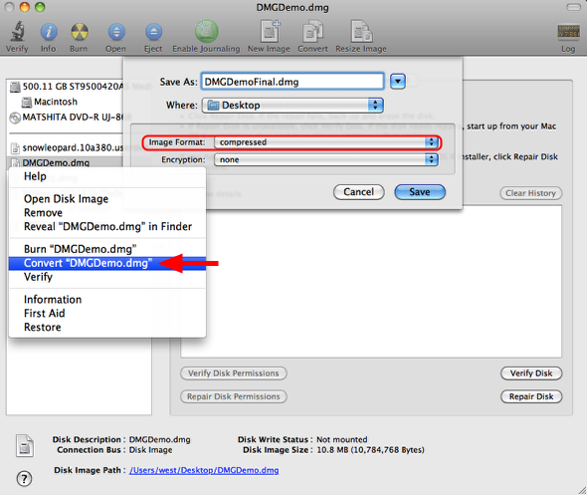

**Step 11: Results**

The DMG was compress and made un-writable, and for this example its now 3.1MB and ready for distribution.

We would love to see some DMG artwork created by our members, so please feel free to post them up here!

